Warrington Soccer
Club

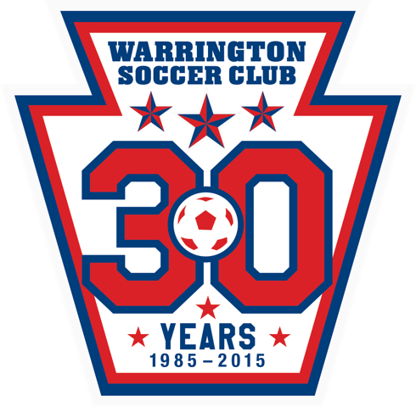
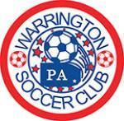

PROUDLY CELEBRATING OUR 30th YEAR
Warrington Youth Soccer League Sponsorship Form 2014 The Warrington Soccer Club depends on local businesses like yours for financial support. By participating as a sponsor, your company can take part in our mission to foster the physical, mental and emotional growth and development for kids in a fun, healthy and competitive environment.
Sponsorship Level: ( check one)
Ultimate Level - $2499 ____ (Company name on back of 10 Intramural Team shirts, a plaque with team photo, hyperlink on club website, 4 e-mail blasts sponsorships throughout the year, and 12 Union tickets)
Master Level - $999 ______ ( Company name on back of 4 IM Team’s shirts, a plaque with team photo, hyperlink on club website for 1 year, Business name on field sign AND 4 tickets to a Union Soccer game)
Platinum Level - $699 _______ ( Company name on back of 3 IM Team’s shirts, a plaque with team photo, hyperlink on club website for 1 year and Business name on field sign)
Gold Level - $499 _______ ( Company name on back of 2 IM Team’s shirts and a plaque with team photo)
Silver Level - $299 _______ ( Company name on back of 1 IM Team’s shirts and a plaque with team photo)
Bronze Level - $199 _______( Hyperlink on club website for 1 year)
Company Name: _____________________Website (URL): _________________________________________
Contact Name: _______________Phone Number: _________________ E-Mail: ___________
Credit Card information: ( Visa, MC, Discover) __________________________ Exp Date: _____________
PLEASE ATTACH A BUSINESS CARD OR AD FOR WORDING TO BE INCLUDED
Please complete this application and return it with your check made payable to: Warrington Soccer Club, Attn : Sponsorship Director, P.O. Box 605, Warrington, PA 18976
For more information please contact: Jodi Curry 215-805-0204 or Jim Keyser 215-343-7470
Warrington Soccer Club is a non-profit (501)(c)(3) volunteer organization serving local youths and families in the Bucks and Montgomery area. Thank you for supporting the Warrington Soccer Club

